Assignment Deploy Any PHP application on Kubernetes cluster

Updated Directory Structure
todo-app/
│
├── index.php
├── simple_todo.sql
├── Dockerfile
├── docker-compose.yml
├── k8s
├── mysql
├── php-app
├── phpmyadmin

This all files I have uploaded on my github profile you can check this on this url
https://github.com/Abhijeet41/3tier_todo_app
Step 1: modify some changes in index.php
Replaced this line
$connection = mysqli_connect('localhost','root','','simple_todo');
with
$connection = mysqli_connect('db','root','rootpassword','simple_todo');

Step 2: Install Docker in Ubuntu Ec2 Instance
Already installed docker using below reference link https://www.digitalocean.com/community/tutorials/how-to-install-and-use-docker-on-ubuntu-22-04

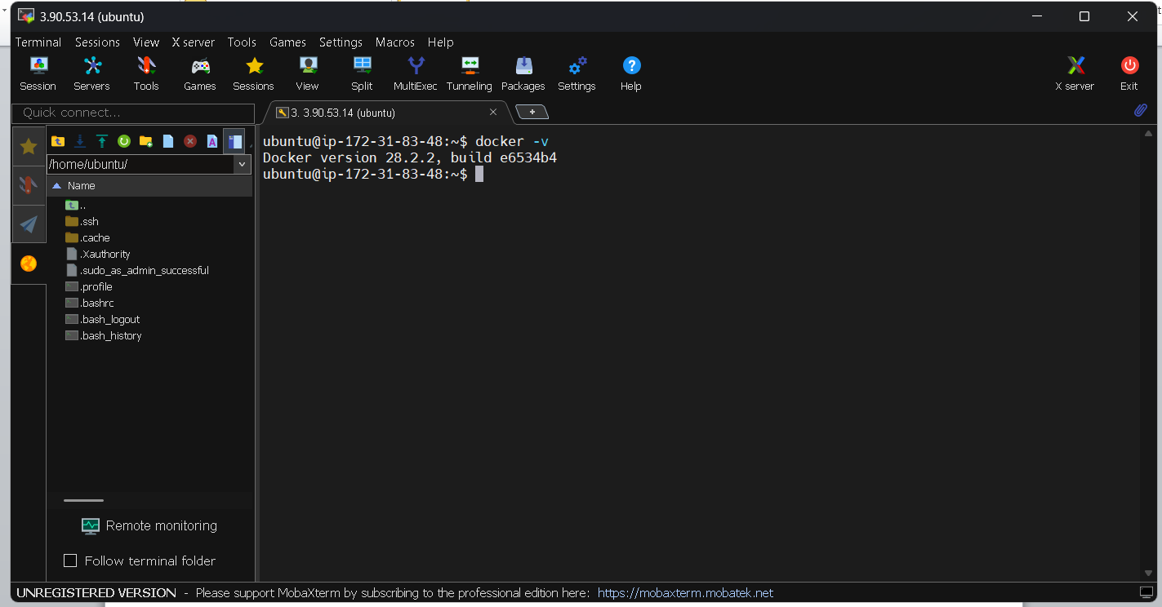

Step 2.1 :- Dockerfile for PHP-Apache
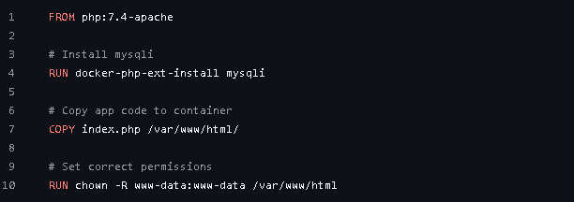

Step 2.2 :- docker-compose.yml File

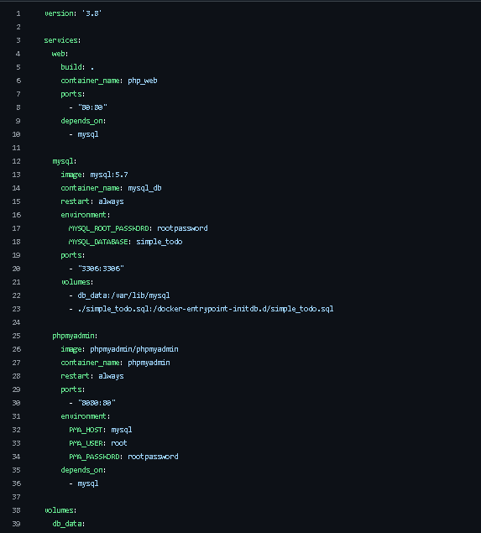

Step 2.3 :- Build and Run
docker-compose build
docker-compose up -d
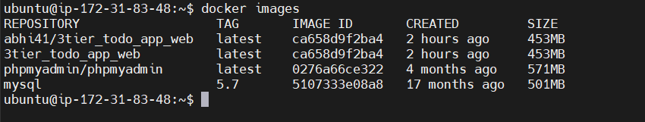
Step 2.4 :- Upload php-app docker image on docker hub later we used for k8s
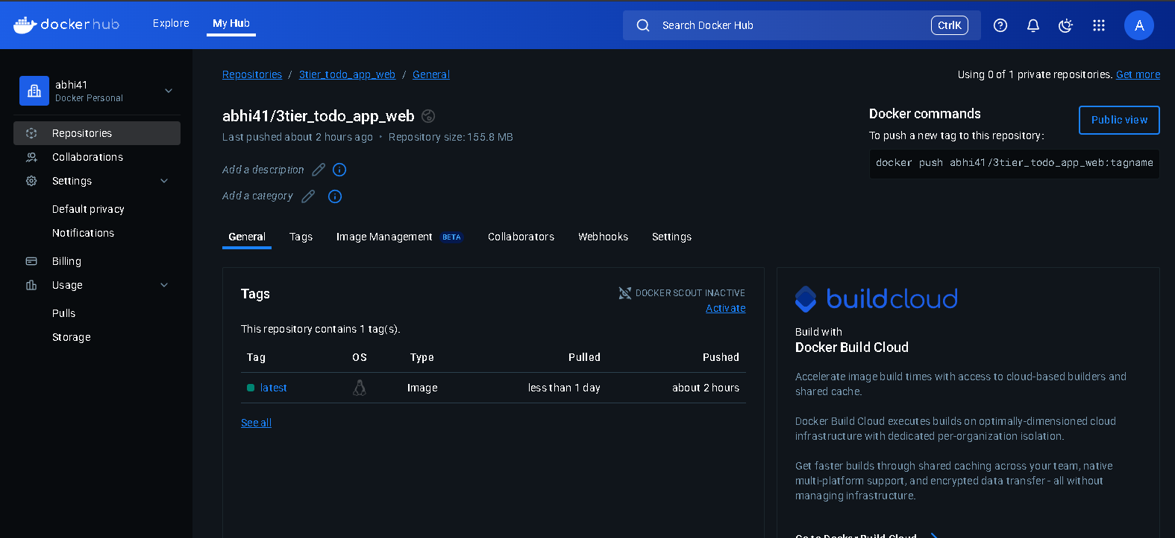

Step 3: Configure Kubernetes cluster setup in aws
I have already configure my k8s using kops
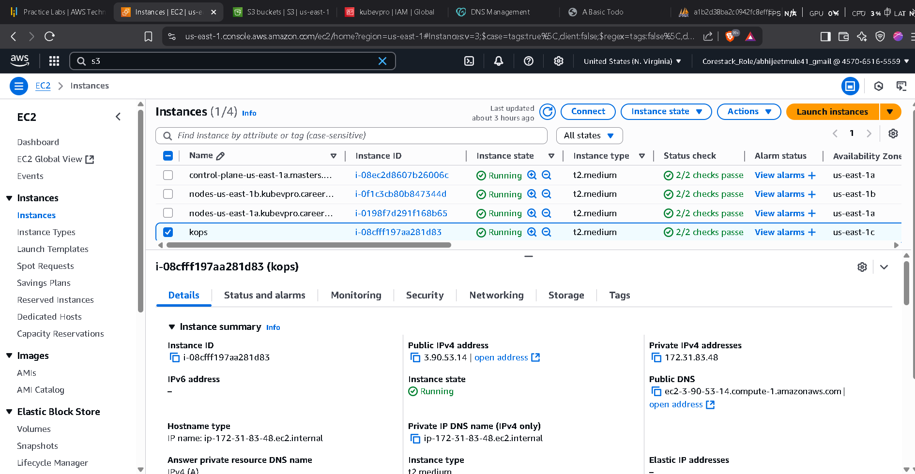

Now new updated Project Structure for k8s
k8s/
├── mysql/
│ ├── deployment.yaml
│ └── service.yaml
├── php-app/
│ ├── deployment.yaml
│ └── service.yaml
├── phpmyadmin/
│ ├── deployment.yaml
│ └── service.yaml

Now Step By Step Deployment Starting with MySql first
2. MySQL
mysql/deployment.yaml
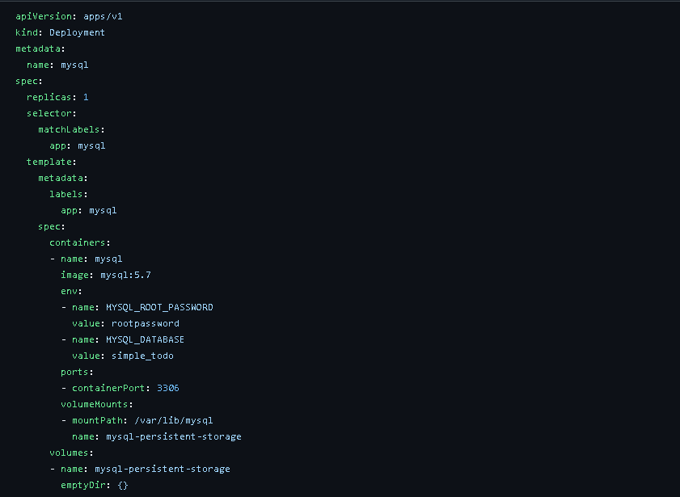

k8s/mysql/service.yaml
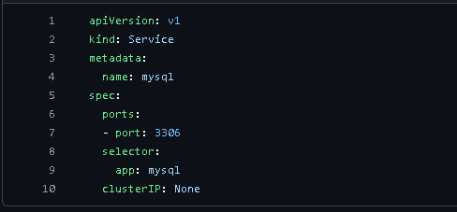

2. php-app
k8s/php-app/deployment.yaml
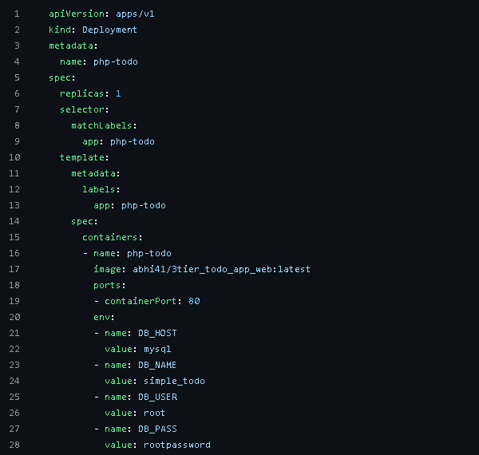

k8s/php-app/service.yml
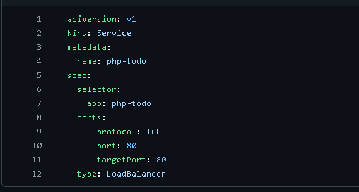

3. phpmyadmin
k8s/phpmyadmin/deployment.yaml
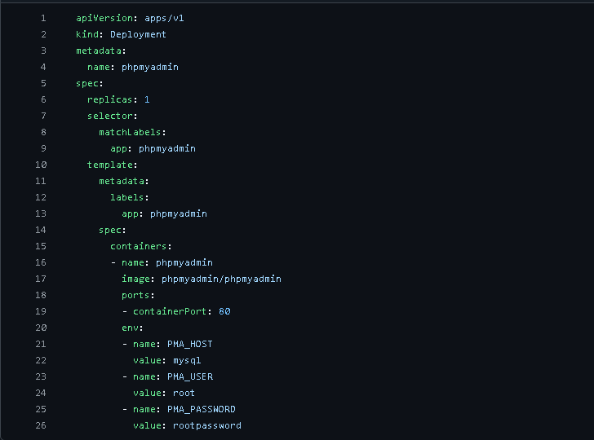

k8s/phpmyadmin/service.yaml

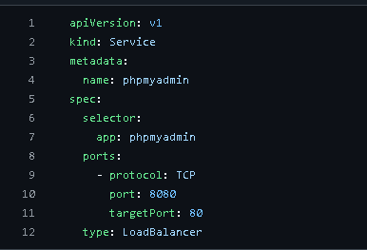

Now Create or Apply All Deployment and Service file using below commands
kubectl apply -f k8s/mysql/
kubectl apply -f k8s/php-app/
kubectl apply -f k8s/phpmyadmin/

kubectl get svc
O/P
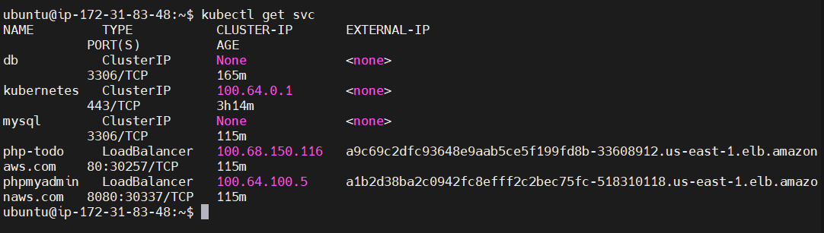
This for my php app
http://a9c69c2dfc93648e9aab5ce5f199fd8b-33608912.us-east-1.elb.amazonaws.com/index.php
This for my php admin
http://a1b2d38ba2c0942fc8efff2c2bec75fc-518310118.us-east-1.elb.amazonaws.com:8080/index.php
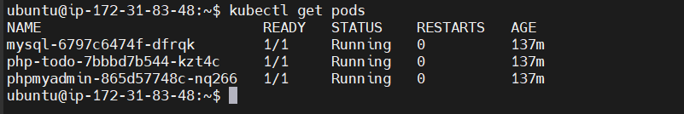
Now Final Output on Web Browser

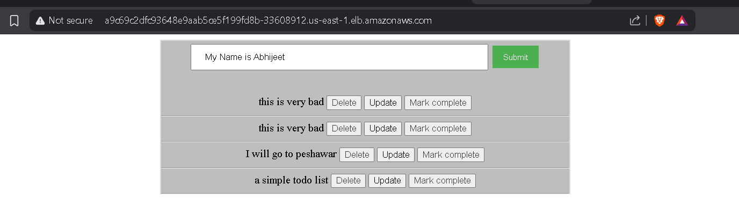

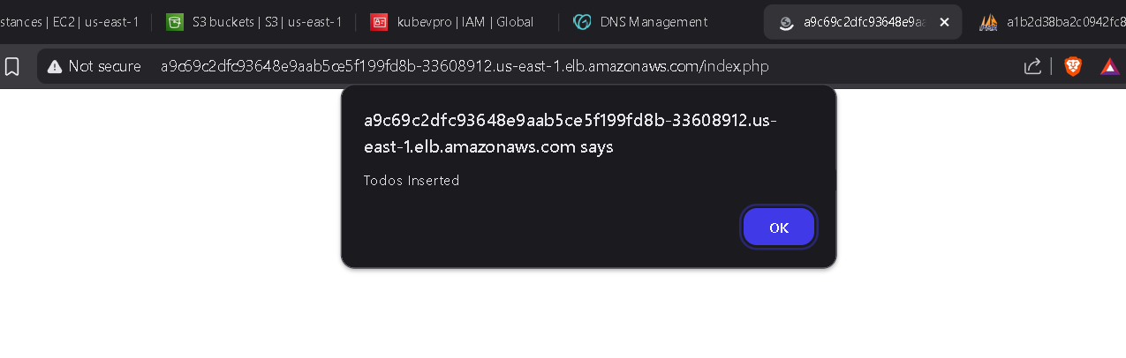
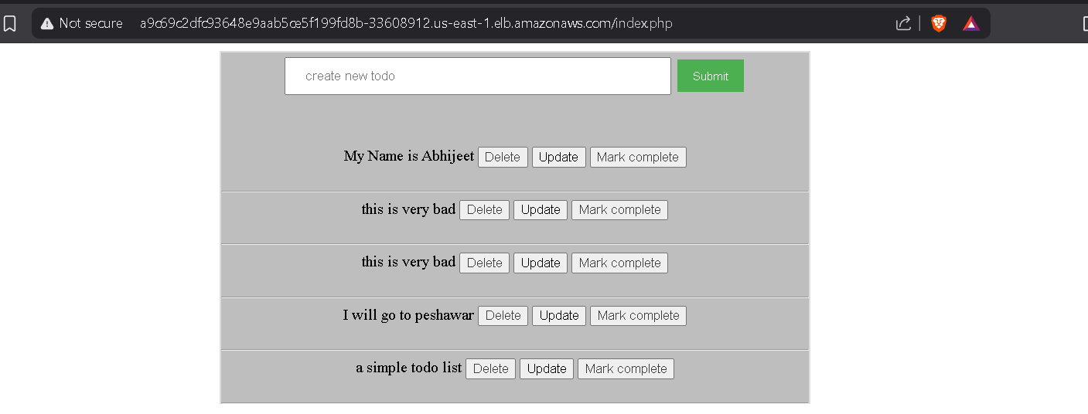

We can checked our value inserted in Database

